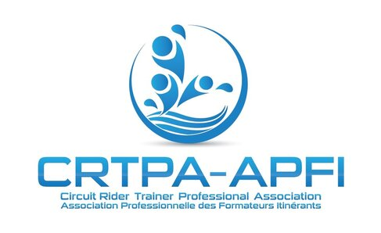 | National First Nations Water Leadership Award Bursary Application Form (2021)

The Circuit Rider Trainer Professional Association is proud to offer the National First Nations Water Leadership Award Bursary program. The bursaries will be awarded to a First Nation applicant that is pursuing or furthering their career in the Water and Wastewater industry.
Eligible expenditures for bursaries include the following:
- Water industry Conference/event attendance, travel and accommodations/meals
- Courses to prepare to complete the Water and Wastewater Certification Exams
- Grade 12 GED testing
- University or college courses (related to attaining Level III and above certification and for professional development)
- Other courses to benefit someone in the Water and Wastewater industry will be considered.

Applicant Information:

Name: | Employer:
Address: | Position:
Phone:
E-mail:
Please describe the course/program/event which you are seeking a bursary for, and how it will benefit you in your work within the Water and Wastewater industry
Reference: (Name, Phone, Email)

Please forward your completed application to: admin@crtpa.com
Application Deadline: March 31, 2021

